**Professor Nathaniel Derbinsky**

**Database Management Systems Fall 2017 Section 2**

**Submission Date – 10 December 2017**

**Due Date – 11 December 2017**

TEAM MEMBER 1

NAME: Bingqi Liu

MS Electrical and Computer Engineering Spring 2016

liu.b@husky.neu.edu

TEAM MEMBER 2

NAME: Mitresh Pandya

MS Computer Science Fall 2017

Pandya.mi@husky.neu.edu

TEAM MEMBER 3

NAME: Syed Aman Alam

MS Computer Science Spring 2017

Alam.sy@husky.neu.edu

TEAM MEMBER 4

NAME: Yue Cheng

MS Electrical and Computer Engineering Fall 2017

cheng.yue@husky.neu.edu

**Abstract**

From a bird eye view, the problem being solved is to store data in a permanent storage for a website which offers a service and thus the problem is to store all the data the revolves around the transactions done in providing such a service and the child services for that website. Thus, each and every action taken under the umbrella of services provided by the website should be tracked, stored, analyzed, distributed and ultimately used in an efficient manner to fulfill the goals of both the client and the website provider. This information should be available all the time to all the users associated and the website as well to keep such a service running efficiently.

The solution provided was a database - MySQL chosen by us but there were alternatives. The solution started with hearing what the website owner wants to track and how s/he wants to store (tables involved), what criteria is important (normalization) and how any particular set of data should be identified (indexing). The idea/ requirements were taken from the narrative provided by the website owners to us and we converted that idea into a real working database that can be started in under 2 minutes and can be kept running all the time (How to start and setup this database is shown in video as well).

The service involved was related to providing training/education and the user involved was by default considered a student. A student can obtain multiple roles and the service offers courses which are prepared by faculty members. These faculty members can also extend their education and take courses and also get involved in administrational area of this service. Thus, the roles of faculty/administration/student are interchangeable and by default everyone is a student. All the information of these roles being changed are tracked by the database and which user falls under which category, and when they make the transition. Since the main service provided is providing courses, every enrollment and completion of course, date and time of enrollment/completion, interests and certificate delivery are tracked by the database. The courses involved are broken into course materials just like chapters which have to be completed in a set sequence but since this is a modern website – a chapter can be quiz, post, video, link etc. All these types are also tracked and which course material is completed by which student and created by which faculty is also tracked and is part of the solution. Every course has a primary agenda and some secondary topics that it deals with – again tracked. It is assumed that when a student enrolls and studies course, s/he will be curious and will come up with questions which is highly encouraged and each and every question is tracked and forwarded to the creator of course. All such transactions are monitored for future purposes with the aim to improve the quality of course. If a faculty finds a question interesting, they can make the question public so that everyone can benefit from it. At the end of courses, feedback is highly encouraged so that the quality of content is revised and enhanced using the constructive feedback and the ratings provided.

A special sub problem that was tackled was how to make this website (trainly.io) special and how to differentiate it from others. The solution provided by us was to develop a special feature can playlists – every student can make their playlists of course materials – add course materials, remove course materials and customize it to his/her wish. The student can make multiple playlist on different areas say some course materials student finds difficult or some course materials s/he finds very interesting etc.

Ultimately the solution was provided in the form of a database and we worked as Lead Engineers for trainly.io and provided the services and developed solutions for the above problem.

**A detailed textual description of the problem**

1. A Student has a unique Student ID, email, first name, last name, password, profile picture, contact details (phone number and type), and an address. The address contains street, city, postal code, state and country. Due to security issues, we should not directly save user’s password in the database: standard security procedures(salting/hashing) to protect user’s password should be observed.
2. A user is by default a student and may fall in either/both/none category for administrator and faculty.
3. Faculty are the creators of courses. When a faculty creates a course, we save the date when faculty create a course.
4. Faculty are validated by administrators. When a faculty is validated by an administrator- their work website, the time of verification, affiliation and title must be recorded.
5. For any enhanced positions, an admin takes: Administrators must be granted by another administrator who is grantor– for purposes of security auditing, the approval time must also be recorded.
6. Students can enroll in different courses. Each course has a unique Course id, name, description, icon, cost and a faculty creator. When a student enrolls, or completes a course, the enroll date/time and completion date/time should be recorded. This completion date/time serves as a marker to track the issuance of certificates. When student pays for a course, the payment code is also recorded. After student completes the course, student can give their feedback about the course which includes a rating on a scale of 1-5 and some comments for improvement.
7. Each course has a primary topic, as well as any number of secondary topics. Every topic has a unique Topic ID and name.
8. Every course contains its own materials, which is also created by faculty. Every material has a name, type ID, unique course ID and course material ID. This unique course material id is just to track of order of sequence. The student’s completion status of each and every course material should be tracked- if one student completes all the course material, s/he also completes that course, and hence the completion status and date of each and every course material and course is tracked.
9. Course material can fall in one of four types: a downloadable file (Type 1), a link (Type 2), a post (Type 3), or a quiz (Type 4). We have given types to all course material types so that we can easily recognize simply from the number that what kind of content that course material is and we do not have to check with any other table. Downloadable files have a path, size, and type (used to provide MIME information). Links have a URL and are tagged as video or not. A post just has a large block of text. A quiz comprises a minimum passing score, and a sequence of multiple-choice questions. The quiz has a sequence of questions.
10. Each question in quiz has a unique number (not necessarily the number shown to user), a text, and a set of answers (each with a text, and indication of correct or not). All questions are taken from a single question bank and thus each question can be identified alone. After a student provides an answer, they will receive the feedback and it will also be indicated whether the answer is correct or not. Thus, every question will have a set of answers which have an indication of correctness and a text associated with the answer.
11. As students progresses in a course, they will have many questions when they read different course materials. Every question has a unique question ID. If any of the creators believes the question will be of use to other students, s/he makes the question visible and supplies an answer. If the question shows up, other students can rate questions and give high ratings to questions they find useful, we can calculate the total ratings to make a rank on different question.
12. Each playlist belongs to a student. Also, one student can have many playlists. Every playlist has a unique name which identifies it. Each playlist can have lots of course material which a student is interested in or maybe finds difficult or anything. The student can customize his/her playlist – add playlists/course materials, update, delete course materials, delete playlists etc.
13. Students will have many questions when they read different course materials, every question have a unique question ID. If any of the creators believes the question will be of use to other students, s/he makes the question visible and supplies an answer. If the question shows up, other students can rate questions they find useful with higher rating; we can calculate the rating to make a rank on different question.
14. The main tracking of course and its progress/completion is done at two points – when s/he enrolls and when s/he progresses/completes.

*_____________________________________________________________________________________*

**ER diagrams**

Below are the ER Diagrams added in the document. But Word has its limits and if an ER Diagram is not visible clearly, we have also uploaded a higher resolution version to a file sharing website - <https://ibb.co/cqErvG> . Please refer to it, if something is not clear enough.

**

Student sub-view:

course sub-view:



Course material sub-view:

Playlist Subview:

**– Normalized relations:** There is no deviation from 3NF and all tables are normalized. All primary keys are underlined and foreign keys shown with arrows. If this is not clear enough, we have also created a higher quality version of it (which does not fit in this document – refer to this image sharing link- <https://ibb.co/kLeyqG> Just download the image and zoom and it will be a lot easier to check).



**Physical design**

In general, if an ERD is converted to relational diagram properly, there won’t be a need for denormalization (unless we have special constraints/needs). So, we did not had to do any denormalization. Below is each of the tables we made and all the attributes/columns involved. If in a table, two keys are listed as primary keys, then they both combine to be a single Primary Key and are not individually primary keys.

|  |  |  |  |
| --- | --- | --- | --- |
| Table | Column | Datatype | Notes |
| Student | U_ID | INT (10) | Primary key (Obvious Key as it gives all other columns) |
|  | First name | VARCHAR (255) |  |
|  | Last name | VARCHAR (255) |  |
|  | Email | VARCHAR (255) |  |
|  | Salt number |  |  |
|  | Hash | VARCHAR (40) |  |
|  | Street | VARCHAR (255) |  |
|  | City | VARCHAR (255) |  |
|  | Postal code | VARCHAR (10) |  |
|  | Country | VARCHAR (255) |  |
|  | Profile picture | LONGBLOB |  |
| Faculty | U_ID | INT (10) | Primary key  Foreign key to Student (Faculty is also a student) |
| Admin | U_ID | INT (10) | Primary key  Foreign key to Student (Admin is also a student) |
|  | Grantor-ID | INT (10) |  |
|  | Approval-time | TIMESTAMP |  |
| Contact-number | U_ID | INT(10) | Primary key  Foreign key to Student being multivalued attribute with student |
|  | Phone-type | VARCHAR(10) |  |
|  | Phone-number | INT(10) |  |
| Validates | Faculty ID | INT (10) | Primary key  Foreign key to Faculty (M-N Relation between Admin and Faculty and hence the PK is the combination of faculty id and admin id) |
|  | Admin ID | INT (10) | Primary key  Foreign key to Admin (M-N Relation between Admin and Faculty and hence the PK is the combination of faculty id and admin id) |
|  | Title | VARCHAR (100) |  |
|  | Affiliation | VARCHAR (100) |  |
|  | Work website | VARCHAR (100) |  |
|  | Data time verify | TIMESTAMP |  |
| Course | Course ID | INT (10) | Primary key (Obvious choice and identifies the course) |
|  | Icon | LONGBLOB |  |
|  | Name | VARCHAR (100) |  |
|  | Cost | FLOAT |  |
|  | Description | VARCHAR (255) |  |
|  | Primary topic ID | INT (10) |  |
| Topic | Topic ID | INT (10) | Primary Key |
|  | Name of topic | VARCHAR (255) |  |
| Secondary topic | Course ID | INT (10) | Primary key  Foreign key to course |
|  | Topic ID | INT (10) | Primary key  Foreign key to topic |
|  | Name of topic | VARCHAR (255) |  |
| Enrolls | Student ID | INT (10) | Primary key  Foreign key to student (Student enrolls in course and M-N enrolls is the relation and hence the compound key comprising of StudentId and CourseId) |
|  | Course ID | INT (10) | Primary key  Foreign key to course |
|  | Is Interested | TINYINT (1) |  |
|  | Enroll date | DATE |  |
|  | Completion date | DATE |  |
|  | Payment cod | INT (10) |  |
|  | Ratings | DECIMAL (2,1) | 1≤rating≤5 |
|  | comment | VARCHAR (100) |  |
| F_creates_c | Faculty ID | INT (10) | Primary key  Foreign key to faculty |
|  | Course ID | INT (10) | Primary key  Foreign key to course (PK is the compound key comprising of FacultyId anc Course ID as it is the M-N relation between Faculty and Course) |
|  | Date of creation | DATE |  |
| Course material | Course ID | INT (10) | Primary key  Foreign key to course |
|  | Course material ID | INT (10) | Primary key |
|  | Name | VARCHAR (100) |  |
|  | Created by faculty | INT (10) | Foreign key to F_creates_c |
|  | Type ID | INT (4) |  |
| File | File course ID | INT (10) | Primary key  Foreign key to course material |
|  | File course material ID | INT (10) | Primary key  Foreign key to course material |
|  | Type | VARCHAR (20) |  |
|  | Size | VARCHAR (20) |  |
|  | Path | VARCHAR (255) |  |
|  | Type ID | INT (1) |  |
| Link | Link course ID | INT (10) | Primary key  Foreign key to course material |
|  | Link course material ID | INT (10) | Primary key  Foreign key to course material |
|  | url | VARCHAR (255) |  |
|  | Video | TINYINT (1) |  |
|  | Type ID | INT (2) |  |
| Post | Post course ID | INT (10) | Primary key  Foreign key to course material |
|  | Post course material ID | INT (10) | Primary key  Foreign key to course material |
|  | text | VARCHAR (255e) |  |
|  | Type ID | INT (3) |  |
| Quiz | Quiz course ID | INT (10) | Primary key  Foreign key to course material |
|  | Quiz course material ID | INT (10) | Primary key  Foreign key to course material |
|  | Passing score | INT (5) |  |
|  | Sequence | INT (5) |  |
|  | Type ID | INT (4) |  |
| Question | Visibility | TINYINT (1) | DEFAULT 0 |
|  | Rating | DECIAL (2,1) | DEFAULT 1, 1≤rating≤5 |
|  | Answer to question | VARCHAR (255) |  |
|  | Question ID | INT (10) | Primary key |
| Student completes course material | Student ID | INT (10) | Primary key  Foreign key to enrolls (Compound key comprising of Student Id, CourseId and Course Material ID as it is the M-N relation between Student and Course Material) |
|  | Course ID | INT (10) | Primary key  Foreign key to course material |
|  | Course material ID | INT (10) | Primary key  Foreign key to course material |
|  | Completed | TINYINT (1) |  |
|  | Completion data time | DATE |  |
| Quiz questions | Question number | INT (10) | Primary key |
|  | Feed back | VARCHAR (255) |  |
|  | Text | VARCHAR (255) |  |
|  | Course ID | INT (10) | Foreign key to quiz |
|  | Course material ID | INT (10) | Foreign key to quiz |
|  | sid | INT (10) | Foreign key to enrolls |
| Quiz question answer | Text | VARCHAR (255) |  |
|  | Correct | TINYINT (1) |  |
|  | Question number | INT (10) | Primary key  Foreign key to quiz question |
|  | Answer number | VARCHAR (255) | Primary key |
| Course material question relation | Course ID | INT(10) | Foreign key to course material |
|  | Material ID relation | INT(10) | Primary key  Foreign key to course material |
|  | Student ID | INT(10) | Foreign key to enrolls |
|  | Faculty ID | INT(10) | Foreign key to F_creates_c |
|  | Question ID relation | INT(10) | Primary key  Foreign key to question |
| Playlist | Name playlist | VARCHAR (255) | Primary key |
|  | Created by student | INT (10) | Foreign key to student |
| Playlist has course materials | Playlist name | VARCHAR (255) | Primary key  Foreign key to playlist |
|  | Course ID | INT (10) | Primary key  Foreign key to course material |
|  | Course material ID | INT (10) | Primary key  Foreign key to course material |

Above table includes all the tables we created by using DDL in our database trainly. Almost all primary keys type is INT, a fraction of key is VARCHAR.

The fact that they are of type INT here is almost purely arbitrary—or rather, almost arbitrary, because it is actually faster to search on numeric fields in many database engines; hence, numeric fields make good primary keys. That’s the reason why we use every ID as primary key.

VARCHAR is a set of character data of indeterminate length. Its length can vary according with input. So, In reality, We should do some analysis of sample data to determine the length of text fields, to make sure we have enough space to save the date we input. If we set VARCHAR too short, it may end up with a database that cannot capture all the data we need to store. Thus, almost all the time, we have set VARCHAR (255), except in some case where we think that there can’t be an input of that size. So, we then set VARCHAR to smaller size. For example, we set VARCHAR (255) in TEXT or DESCREPTION, because people may input lots of things in these areas. And, we set VARCHAR(20) in TYPE or SIZE, because there don’t need an input of bigger size- just few word or numeric can express the meaning.

Between different table, we have lots of 1-to-1, 1-to-N and M-to-N relationships—the M-to-N relationships were resolved via separate tables. We created relationships between different table by using foreign keys. We also set the constraints on ratings and used bits to set/unset those fields such that ratings are between 1-5.

**Screenshots of your running system**

**1) TASK 1: Register a New User**

Initial State

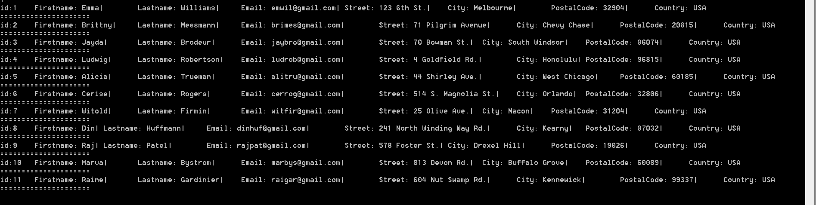

Then we ran task 1 and inputs given fed to command line interface-

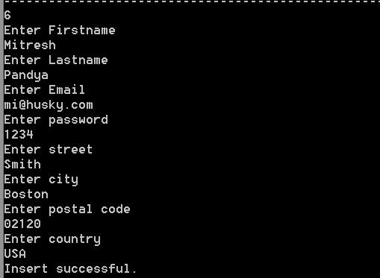

After running task 1, we have the state as:

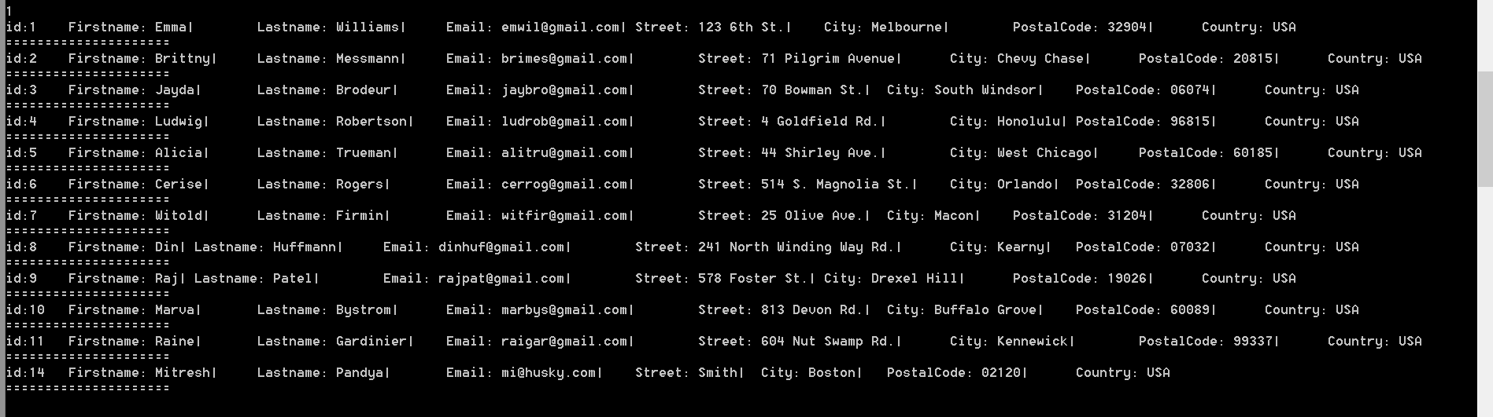

**2) TASK 2:** As an administrator, authenticate a faculty user (based upon title/affiliation/website/email) or fellow administrator

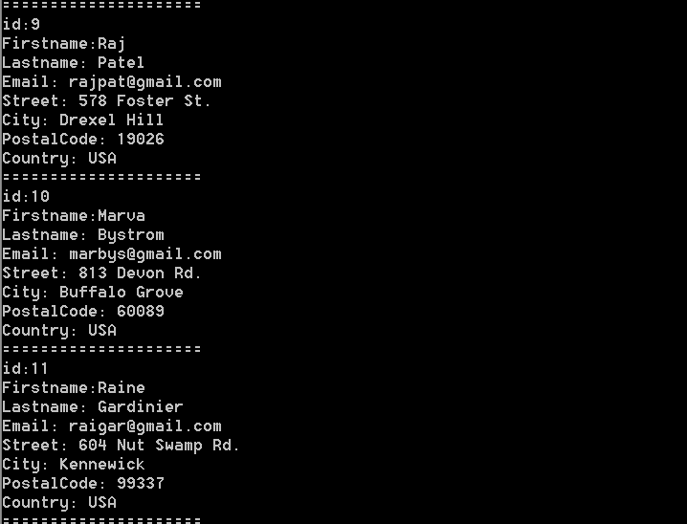Initial State

Entered details for authentication-

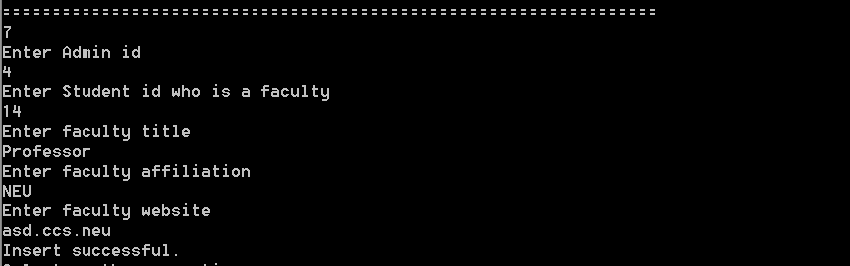

After Insertion-

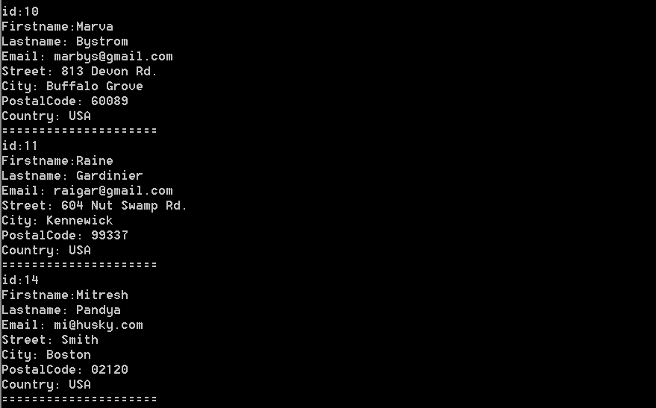

**3) Task 3:** Provide a categorized list of a student’s courses (each with primary/secondary topics, ranked by average evaluation score): currently enrolled, completed, of interest.

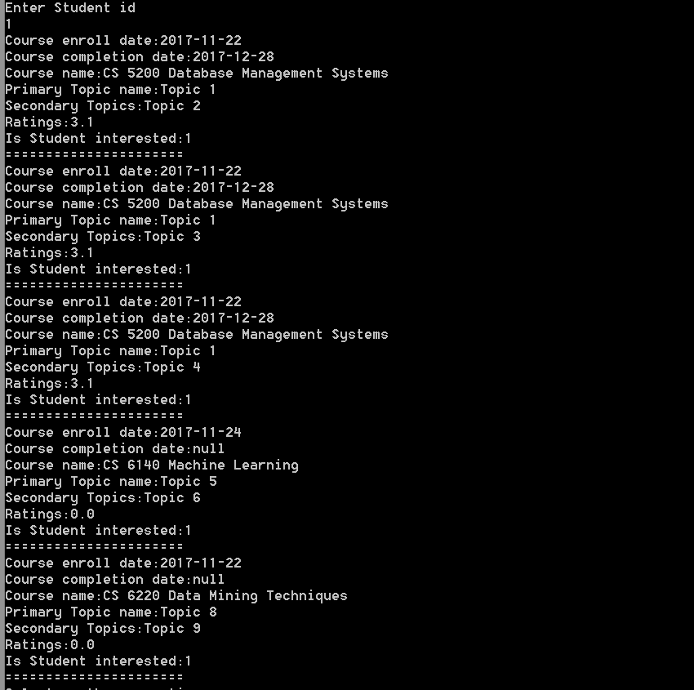

**4) Task 4:** Enroll a student in a course

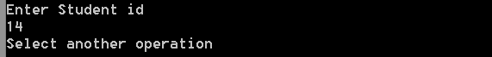

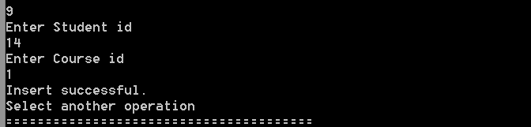

Enrollment Successful. As you can see in the output below that when the student enrolls in a course, s/he is enrolled automatically in all course materials for that course.

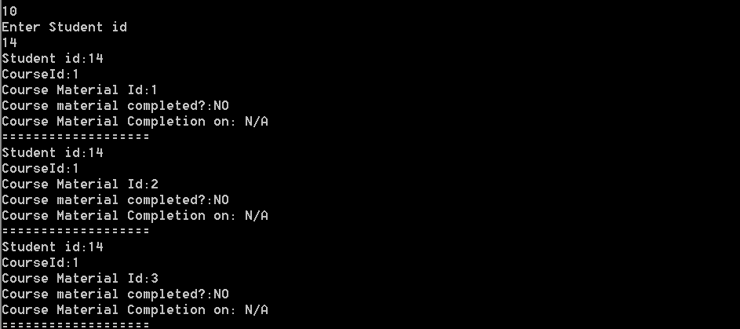

5) Task 5: For a student enrolled in a course, list materials, in order, indicating the line of demarcation between completed/not completed

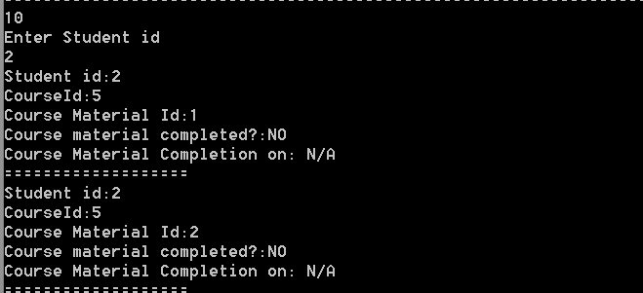

6) Task 6: Mark course material as having been completed by a student (possibly resulting in course completion)

Now a student (Student Id 14 starts with course 1 and all course materials are incomplete).

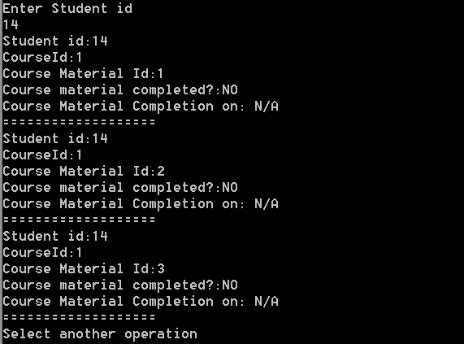

Student then completes course material 1

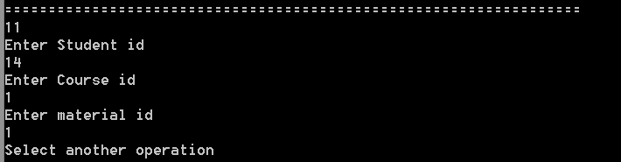

After student completes course material 1, this is the output-

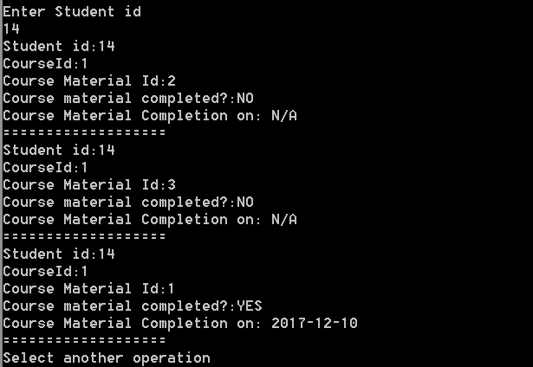

Similarly, the student completes Course Material 2 and this is the output after it:

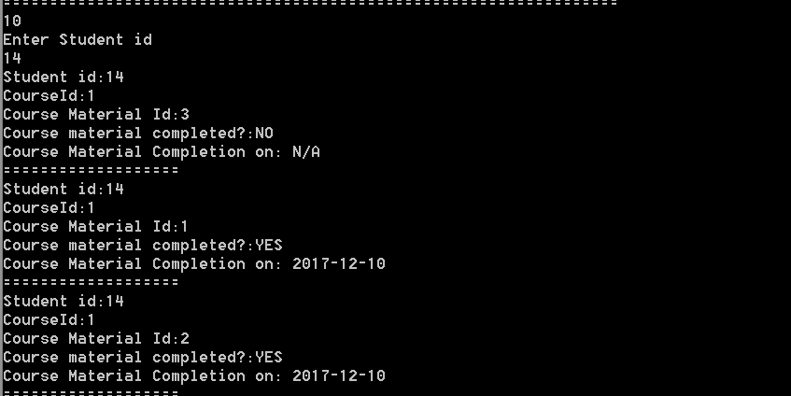

After student completes all the course material in a similar fashion, the enrolls table gets updated as well. Here is the database snapshot-

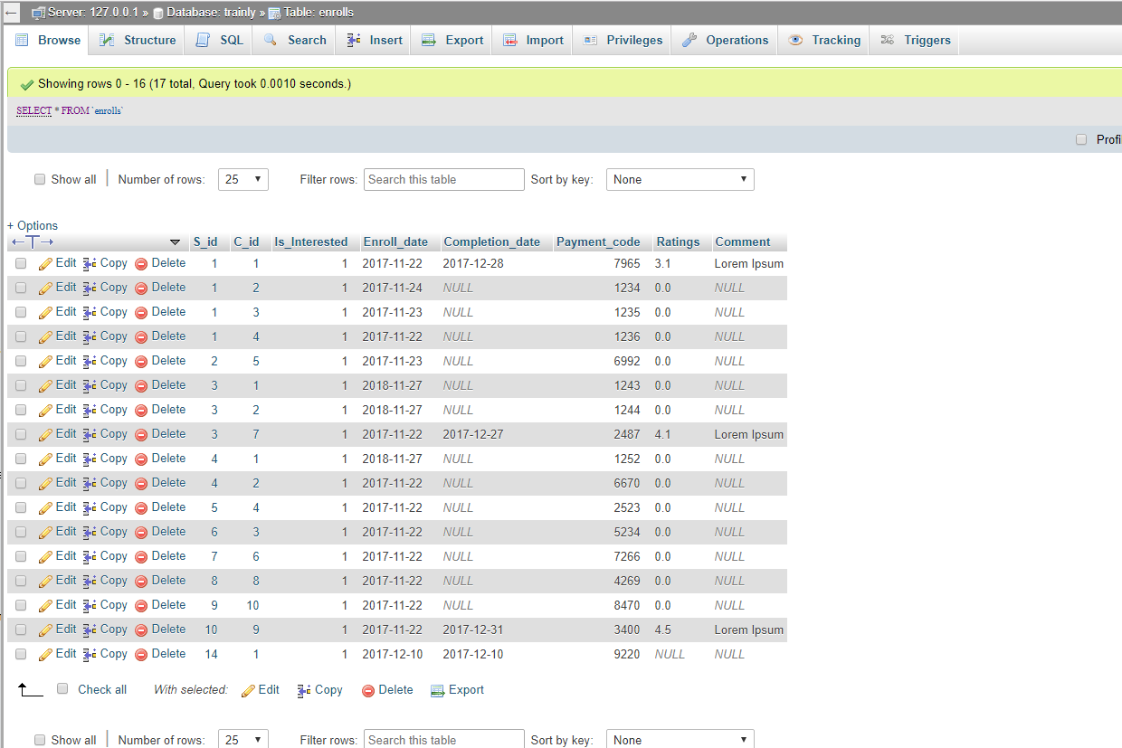

And also the snapshot of our output-

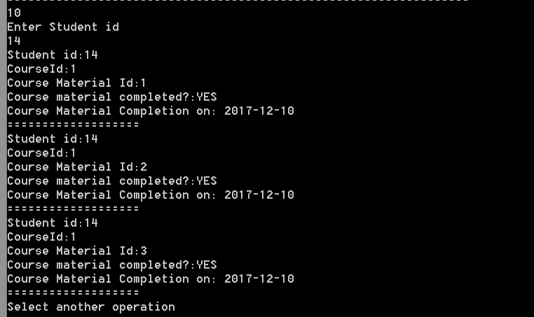

Hence the student completes the course.

7) Task 7: Provide a certificate of completion for a student (assuming s/he has successfully completed all materials)

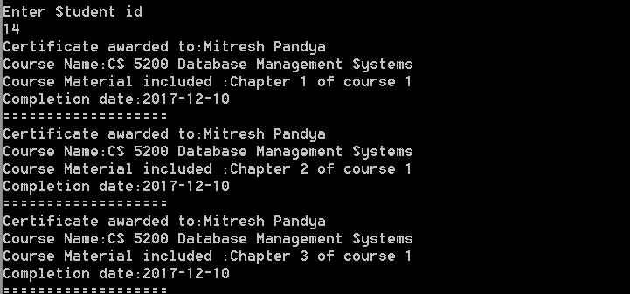

8) Task 8: Provide an account history for a user: dates of enrollment/completion for each course, amount paid (with confirmation code), and total spent.

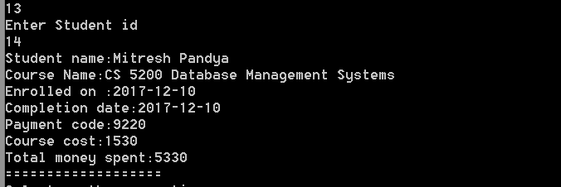

_____________________________________________________________________________________

**Project retrospective**

The project exposed us to all basic required steps of database design and management in a practical setting. At the beginning of the project, we started with the Entity Relationship Diagram and transformed the narrative and specifications into diagrammatic view. Although this is one of the most important step, we did not like it that much. But we later on realized its importance and begin to pay more attention to each and every detail. This is because a properly created ERD, leads to a properly created Relational Diagram and hence we do not need to perform additional steps while writing actual DDL. Hence, we read it word for word, and considered every possible case during the design once we realized its true power. After countless revisions, we finalized the ERD diagram.

We think that the easiest part is ERD diagram but the hardest is also the ERD diagram. Because when we draw the ERD, it is very easy- just make some blocks and connect them. It’s also hardest because we need to make sure it contains all the meaning expressed in the description and it is where the actual transformation of Idea to actual DBMS starts. Thus, if foundation is weak, the whole system will be weak. We also realized that we face a different kind of problem when we are actually filling the sample data using DML. We realized that, many of the tables we actually made did not work well and hence we had to modify the DDL and also the whole chain in backward fashion – DML -> DDL -> Tables -> ERD. So, filling the tables and hence DML part was most enlightening and fun. Hence that was a very good experience. We all think that we learnt a lot from this project. First is, we learnt how to create a complete database management system from scratch and got exposed to all major design steps involved. We also learnt what were the loop holes in our system when filling actual data and hence when we will be designing the database later on, we can use that experience and build a better DDL design. We also learnt teamwork and how to divide the work and yet build a single working system. All of us worked on different parts – One of us worked on ERD, other on relational diagrams, the third one on DDL and DML and fourth one on creating the Java CLI. Although we all took parts in everything, but this was how we divided the majority of tasks.

**Conclusion statement:**

Hence a working Command Line Interface was produced for a database `trainly` for **trainly.io**. This database can be later on integrated with web or mobile interface (Changing to sqlite preferred here for mobile). Apart from this, the logging part is left and the database encryption part and advanced practices were also left. What we have is a fully functional basic database system which can be integrated into almost all systems (maybe with slight modifications) in different sectors of industry (where database is required). We also realized the true power of database and how each and every data and transaction has to be modified according to use cases – what to index, where to index, when to denormalize, how to deal with foreign key constraints when adding data in individuals etc. Overall it was a great learning curve and very enlightening one which equipped us to integrate Databases in all our future projects within limited time frame.

_____________________________________________________________________________________